**Community Policing Report**

Quality of Life Issues

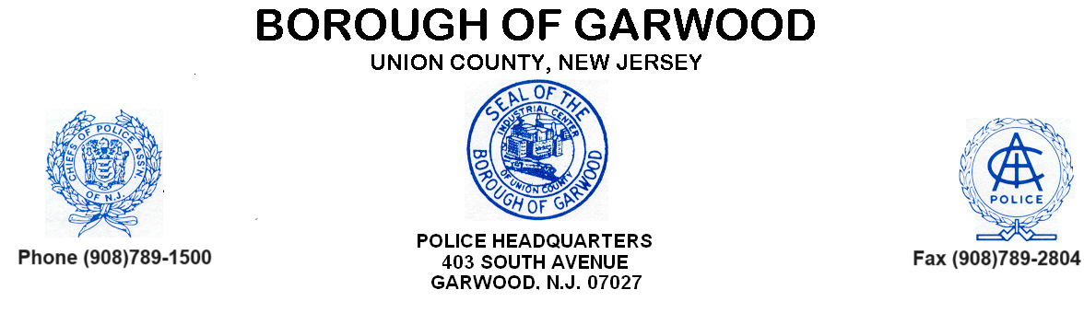

Our goal is to more accessible to the residents, businesses and community. The Garwood Police Department strives to ensure that the concerns of every resident are addressed to the extent our authority allows. We care about those issues in your neighborhood that you feel personally affect your quality of life and encourage you to bring anything to our attention that we may have missed.

**Please note below, any suspected criminal or suspicious activity, traffic issues, property maintenance issues or other quality of life issue you may have observed. Continue on the rear if necessary. Name and address is optional but requested.**

Name: Contact Number:

Address:

Email Address: